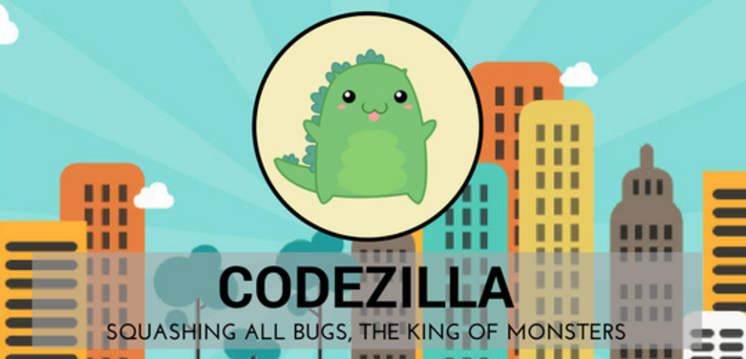

# CODEZILLA MEETING MINUTES

|  |  |  |  |  |  |
| --- | --- | --- | --- | --- | --- |
| Details of Meeting | | | | | |
| Meeting Title | | | Iteration 0 - Sponsor Meeting 1 (Skype Call) – 24032017 | | |
| Date (DD/MM/YYYY) | | | 24/03/2017 | **Time** | 04:00PM – 06:00PM |
| Location | | | School Of Information Systems (SIS) GSR 2-6 | | |
| Minutes Prepared By | | | Zul Yang | **Minutes Vetted By** | Amanda Lim |
| Attendees | | | Zul Yang  Amanda Lim  Nigel Goh  Edward Foo  Koh Xiao Wei  Jolene Teo  Edward Booty (Sponsor) | **Absentees** | - |
| Meeting Objective | | | | | |
| Skype Call with Sponsors to Understand Project better | | | | | |
| Meeting Agenda | | | | | |
| 1. Skype Call with Sponsors 2. Short discussion and planning | | | | | |
| Meeting Notes, Discussion | | | | | |
| S/N | **Topic** | | **Details** | | **To Note** |
| 1 | Use cases and Requirements | | -Basic high level requirements and use cases sent over were scanned through and discussed.  -Used as a starting point to understand project better | |  |
| 2 | ImpactLaunch.Space | | -Refer to set of slides sent by sponsors that give a brief introduction to ImpactLaunch.Space | | There is an additional set of slides on HealthLaunch.Space |
|  |  | |  | |  |
|  |  | |  | |  |
|  |  | |  | |  |
|  |  | |  | |  |
|  |  | |  | |  |
|  |  | |  | |  |
|  |  | |  | |  |
|  |  | |  | |  |
| Actionable Items | | | | | |
| S/N | | **To Be Done** | | **Team Member(s)** | **Due Date (DD/MM/YYYY)** |
| 1 | | Read through and review the Use Cases and Requirements | | All | 03/04/2017 |
| Next Meeting (If Applicable/Discussed) | | | | | |
| Date (DD/MM/YYYY) | | 03/04/2017 | | **Time** | TBC |
| Location | | SMU Labs Meeting Room 2-2 | | **Objective** | Revise the Use Cases and Requirements |
|  | | | | | |